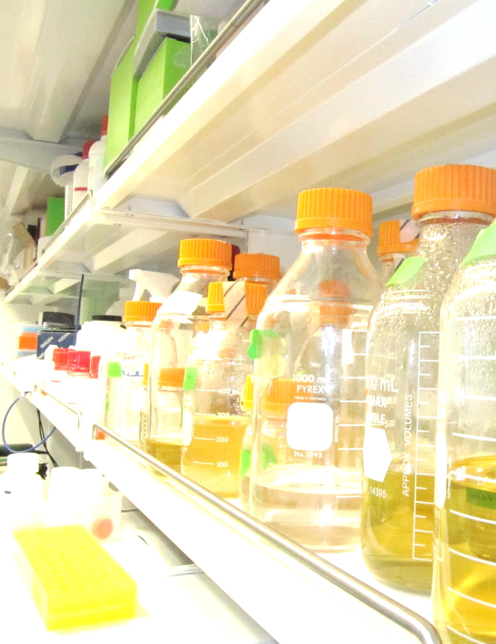

2014 Sponsorship Report

Thank you for your interest in sponsoring the 2014 Cornell Genetically Engineered Machines Team. Each year, our team competes in the iGEM (International Genetically Engineered Machines) competition. iGEM is the world’s premier synthetic biology competition where high school, collegiate, and entrepreneurial teams design and implement novel genetic circuits to help solve the many needs of industry in fields ranging from the environment to medicine.

Team Letterr

This season was a very successful year for Cornell iGEM. With your support, our entirely student run team achieved Gold Medal status at the international competition based on our novel biological and genetic work, human practices, and collaboration with other iGEM teams.

This year, your company reached an audience of 245 multidisciplinary teams from across the world (2,300 participants in total) as well as numerous judges and visitors from leaders of academia and industry at the international competition. We have featured your sponsorship prominently in our presentations, poster, and website. Our presentation along with a video will be available online at<http://igem.org/Results>, under Jamboree Results for iGEM 2014, Cornell in North America. The report below contains a more extensive breakdown of our team, budget, and accomplishments for the 2014 Cornell iGEM team.

Our sponsors play a pivotal role in our success each season. Without the generous monetary support and necessary supplies provided by our sponsors, we would no longer be able to contribute to the scientific community through iGEM’s parts registry or help develop the next generation of biological researchers. Each year, our ideas grow through the support of our sponsors, and we hope to further develop our ideas and skills by partnering with your business.

After this year's training, the subsequent 2015 season promises to be one of our most successful yet. We are very proud to represent Cornell University, the iGEM competition, and all of our sponsors, and we hope that you will join us in our efforts to continue solving the world’s problems via synthetic biology for years to come. We greatly appreciate your support, and we hope to work with you once more in 2015!

Sincerely,



Eric Holmes

Team Leader, 2014

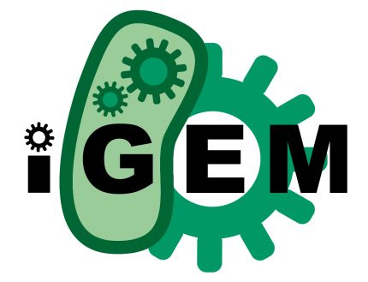**The Competition**:

What is ?

iGEM began in 2003 at Massachusetts Institute of Technology, and has since grown into the world’s largest synthetic biology competition, now hosting 245 teams from around the world in 2014. At the beginning of the season, each team receives a kit plate of synthetic DNA parts from the iGEM headquarters. Using these and parts of their own design, teams integrate synthetic DNA components to create novel, engineered organisms to solve various engineering problems. Teams participate each year at the international competition and are judged based on the quality of their biological work, the significance and applicability of their project, human practices and safety components, and the presentation of the work via their website, poster, and a formal oral presentation.

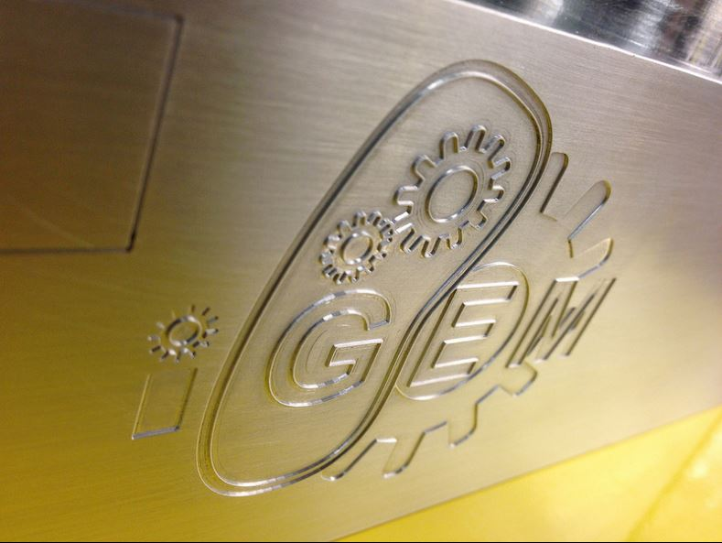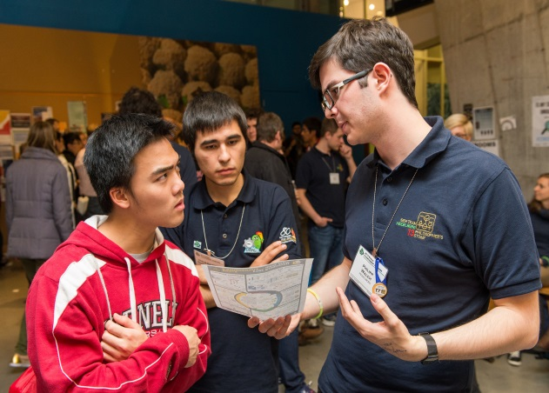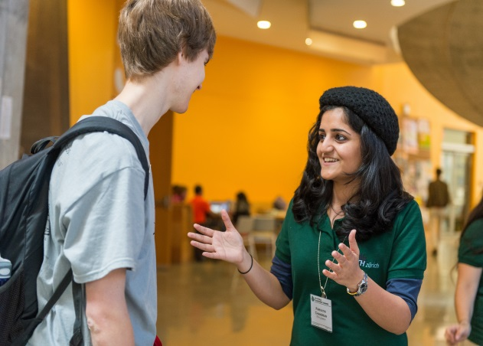

**The Parts Registry:**

One of the iGEM competition’s greatest goals is the development and cultivation of the Standard Registry of Biological Parts. This parts registry contains thousands of synthetic DNA components designed to be modular. That is, every part in the registry can be interchanged within common DNA backbones, allowing researchers to easily create novel genetic circuits for important engineering purposes. After every competition season, iGEM teams submit their genetic parts (called “BioBricks”) to the parts registry for future teams and researchers to use. This collaboration is essential to the iGEM competition and research in synthetic biology in general, and it ensures that any research done by our team can be utilized by the scientific community.

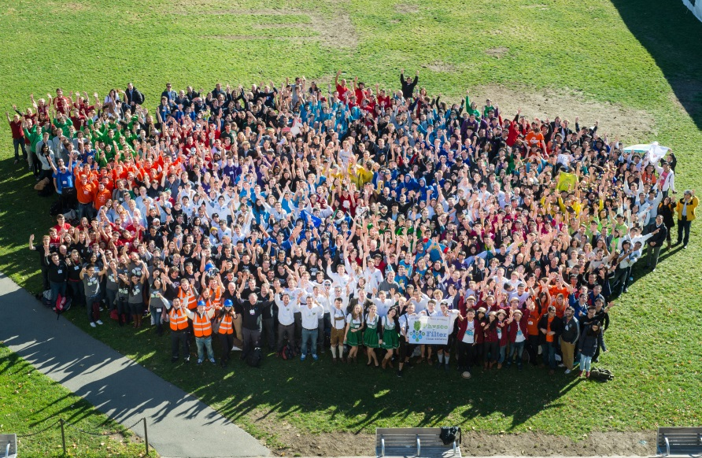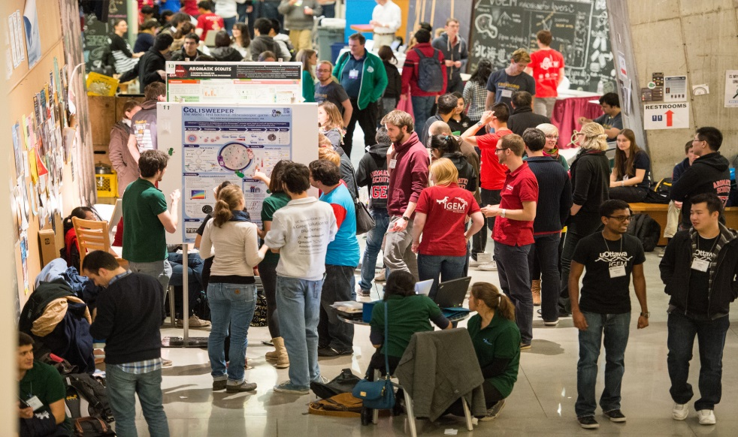

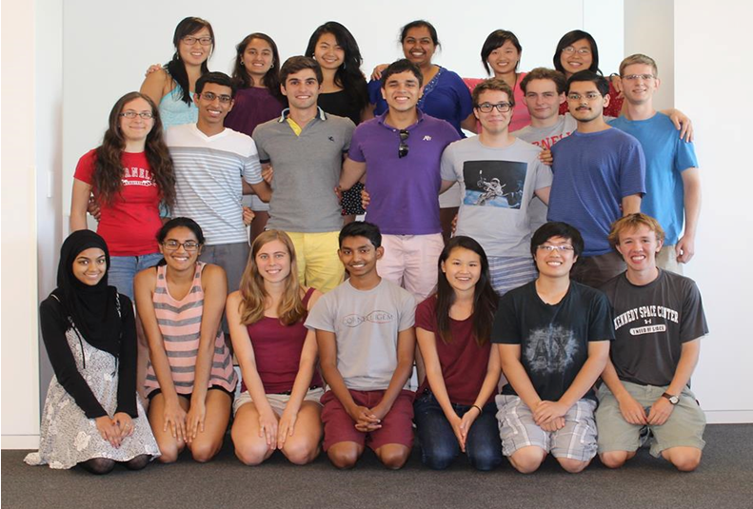

The Team

Cornell iGEM is a student-run undergraduate biology team and has solidified itself as a perennial contender at iGEM competitions. The team is still relatively new, but recent successes have helped the team gain a prominence and reputation at both the university and the iGEM competition.

Our team is composed of 34 undergraduate students from five colleges across the university (Engineering, Arts & Sciences, Agriculture & Life Sciences, Human Ecology, and Architecture). This diverse group of students uses their manifold expertise to complete a complex and novel project each year.

Cornell iGEM provides dedicated students with an interest in biological research and engineering an opportunity to gain experience in a diverse, professional work environment, hone their practical engineering skills, and pursue their own research goals. As evidenced by our recent human practices accomplishments, our team in particular prides ourselves on sharing our research and promoting safety when it comes to the controversial field of synthetic biology. In doing so, we are developing the next generation of responsible scientists with the potential to bring synthetic biology to the forefront of modern engineering solutions.

Team History & Accomplishments

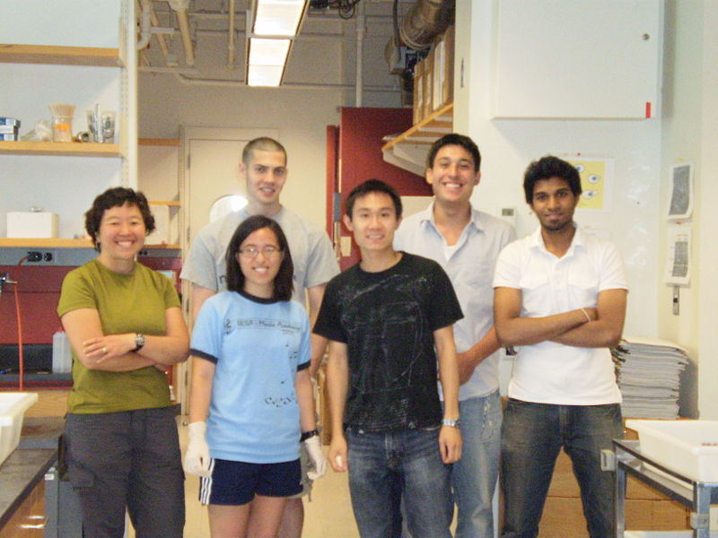

2009-

2010

A small group of Cornell undergraduates comes together to compete in the iGEM competition for the first time, presenting their projects on a cadmium biosensor and outer membrane vesicles.

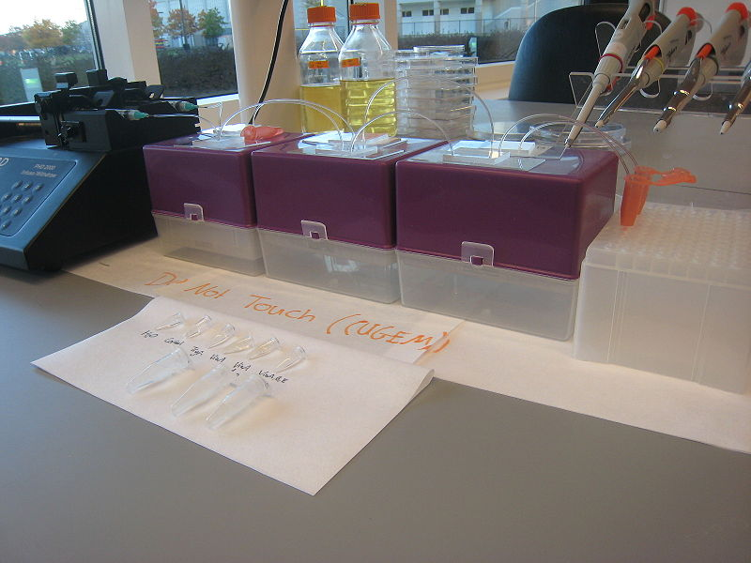

Cornell iGEM wins the best manufacturing project at the international competition for their cell-free method for synthesizing complex biomolecules.

2011

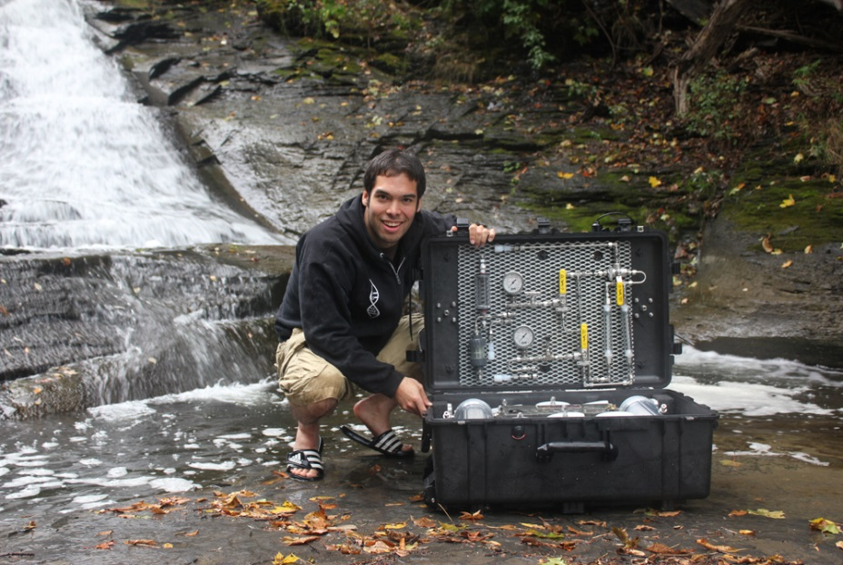

At the America’s East regional competition, Cornell iGEM is a top 4 finalist, gains gold medal classification, and wins both the best wiki and best human practices advance awards.

2012

At the international competition, Cornell iGEM is a top 16 finalist and wins “Best Solution to an Oil Sands Problem” from the Oil Sands Leadership Initiative.

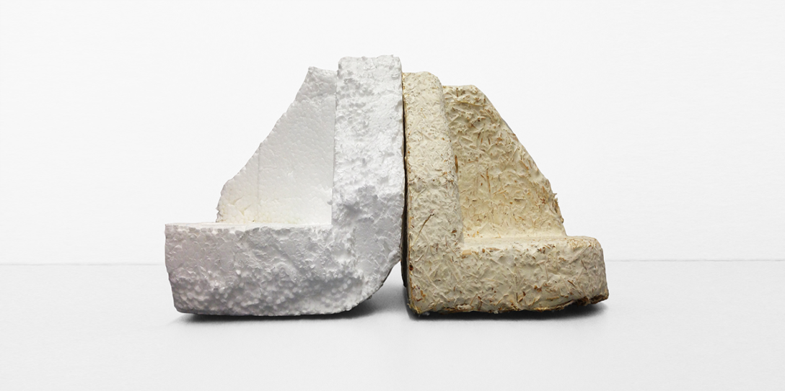

At the North American competition, Cornell iGEM gains gold medal classification and wins best human practices advance.

2013

At the international competition, Cornell iGEM wins best human practices advance.

W2014: Lead It Go

In 2014, our project was entitled Lead It Go, where we improved existing biological filtration methods and developed a novel system for lead remediation. Heavy metal pollution in water is one of the most significant public health risks around the world. We were inspired to work on this project given the proximity of Onondaga Lake in Syracuse, NY, one of America’s most heavily polluted lakes. The old Ithaca Gun Factory is also located ten minutes away from Cornell campus, which has contaminated the local watershed in the past.

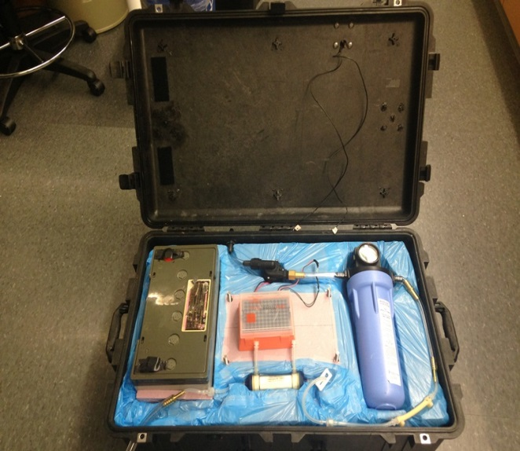

Current remediation techniques are often cumbersome, costly, or result in the production of toxic byproducts, and so we decided to genetically engineer a heavy metal sequestration system with two main components: 1) a metal specific transporter that uptakes heavy metals at the membrane, and 2) a metal binding protein that would permanently capture them intracellularly. Our drylab team also designed a working prototype of a heavy metal filtration system built to last several weeks with minimum maintenance; the prototype is shown in the image to the right. More information on our work in 2014 can be found at <http://2014.igem.org/Team:Cornell>

WHuman Practices and Outreach

Human Practices is broadly defined as the incorporation of any economic, ethical, legal or social dimensions into an iGEM project. This year, we set out to create Human Practices components that contributed to and complemented with the work our team was doing, had a meaningful impact on our local and global communities, and were innovative, novel, and educational to future teams. To this end, we did the following: (1) engaged in extensive outreach, (2) learned about the environmental, social, economic, and political issues that shaped the world of the biochemistry we were tackling, (3) launched a new social media platform called Humans and SynBio in collaboration with teams from across the world, (4) put together a survey to understand the constructs underlying opinions about synthetic biology, (5) built a Comprehensive Environmental Assessment, following up on our efforts from previous years, (6) facilitated collaborations within our university to put together a portfolio of possible implementation of our genetically engineered technologies, (7) reached out to other iGEM teams to collect water samples for testing, and (8) considered the bioethical and safety implications of our work at large.

|  |  |  |
| --- | --- | --- |
| **Expenses** | **Amount** | **Description** |
| Oligonucleotides and Gene Synthesis | $2000 | Primers were used to create and verify our genetic constructs. |
| Software Licensing | $5000 | Software to help us build and visualize our genetic constructs. |
| DNA Sequencing | $350 | Sequencing was used to verify our genetic constructs. |
| Molecular Biology Chemicals and Reagents | $3500 | Some examples are antibiotics, media components, and various enzymes. |
| Plasticwear and Other Miscellaneous Lab Supplies | $3000 | Includes materials such as desalting membranes and electroporation cuvettes. |
| Drylab Supplies | $2000 | Includes mechanical and electrical equipment for drylab team |
| Outreach Supplies and Printing | $200 | Materials such as foam balls and pipe cleaners were used for fun science demonstrations and activities. |
| ***Total Expenses*** | $16,050 |  |

Project Budgetget

Outreach and Competition Budgetet

|  |  |  |
| --- | --- | --- |
| **Expenses** | **Amount** | **Description** |
| iGEM Team Registration Fee | $3500 | Cost for DNA kit plate and to register in iGEM competition. |
| Individual Registration Fee | $6800 | Cost of individual attendance at the international competition. |
| Travel | $1281.25 | Cost to car rental and gas to travel to international competition in Boston. |
| Lodging | $2148 | Cost of 2 hotel rooms in Boston for 4 nights. |
| ***Total Expenses*** | $13,729.25 |  |

2014 Accomplishments

1. We have created functional metal sequestration systems for nickel and lead and have tested water samples from across the US.
2. We have built a working prototype for direct application to industry: a heavy metal filtration system built to last several weeks with minimum maintenance.
3. We achieved Gold Medal Status at the international competition and were highlighted by Elsevier Journal for our efforts.
4. In addition to numerous outreach activities for the local community, we have launched a new social media platform called Humans and SynBio designed to spread awareness of synthetic biology.

Sponsorship Benefits

**Competition Visibility:**

Each year, Cornell iGEM competes at the largest international synthetic biology (245 teams in attendance with 2300 participants). All of our sponsors are featured prominently on our competition poster, competition presentation, and project Wiki. Our team website and competition Wiki from this past competition season (on which all of our sponsors are featured) both receive around 500 hits per month. Due to our success the past couple seasons, our team has been featured in various publications including Elsevier, the Cornell Chronicle, the Cornell Daily Sun, IDT’s Decoded, and Popular Science, as well as newsletters from our past and current sponsors.

**University Networking:**

Cornell University is a highly respected and well regarded research university. At the university, sponsors can gain exposure through team interactions with other students and members of their other research endeavors. As a relatively new team, we have a very young and active alumni network with whom we communicate our sponsors, and each year we have graduating members who are eager to pursue careers in biology and engineering — quite possibly with a sponsor.

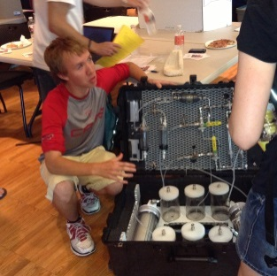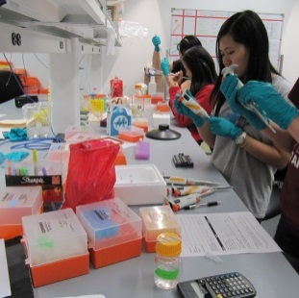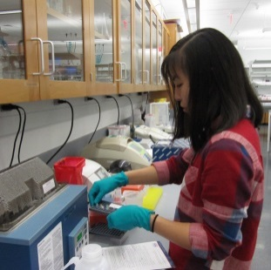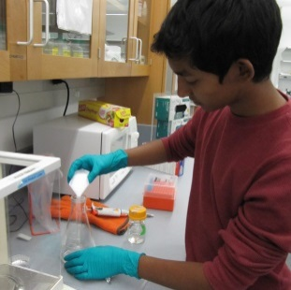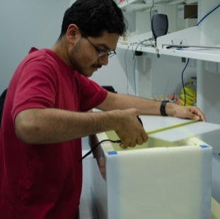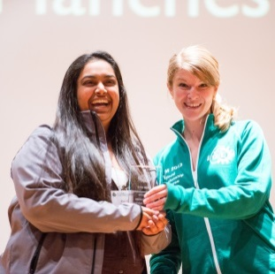

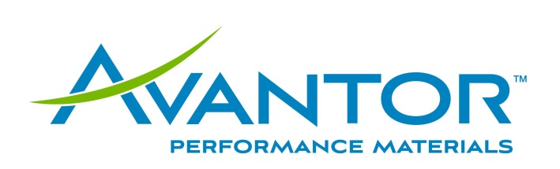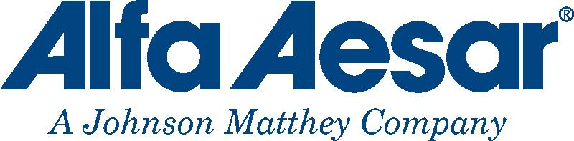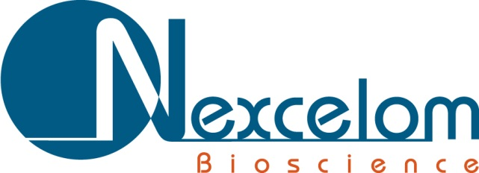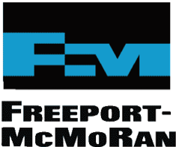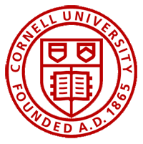  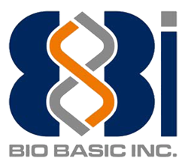

Thanks to our 2014 Sponsors!